**Q1.Try Test-Connection and nslookup commands for below websites:**

* [**www.google.com**](http://www.google.com)
* [**www.facebook.com**](http://www.facebook.com)
* [**www.cisco.com**](http://www.cisco.com)
* [**www.github.com**](http://www.github.com)
* [**www.amazon.com**](http://www.amazon.com)

**Test-Connection Command:**

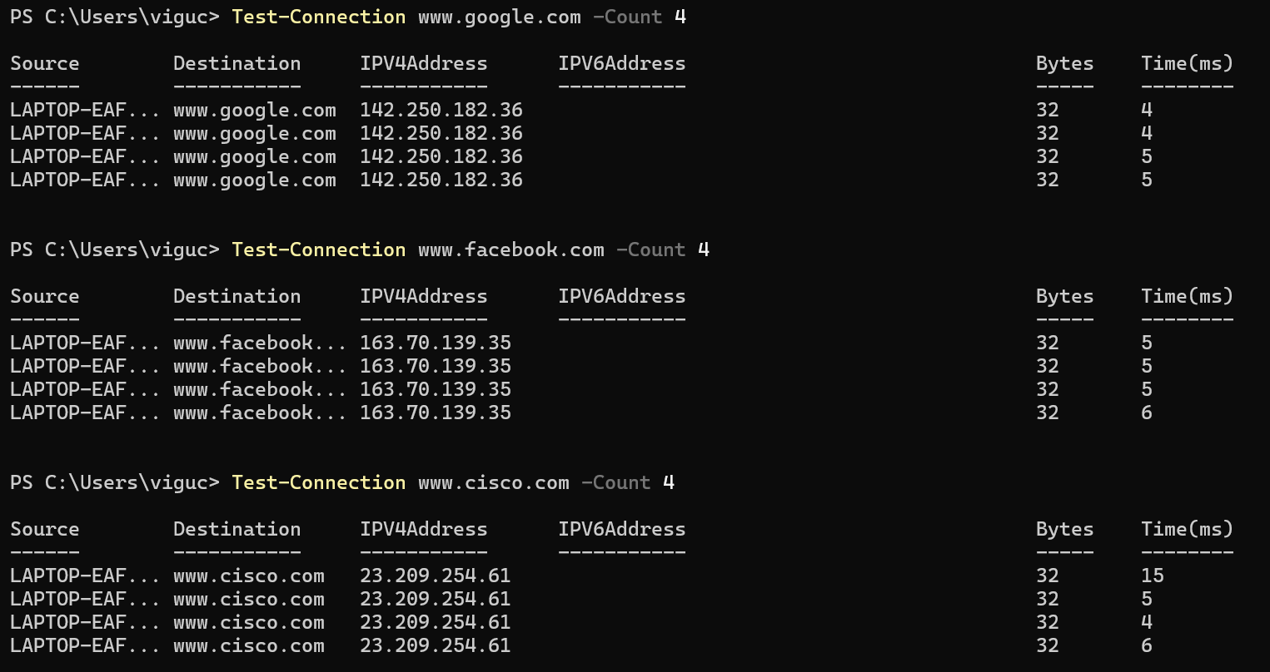

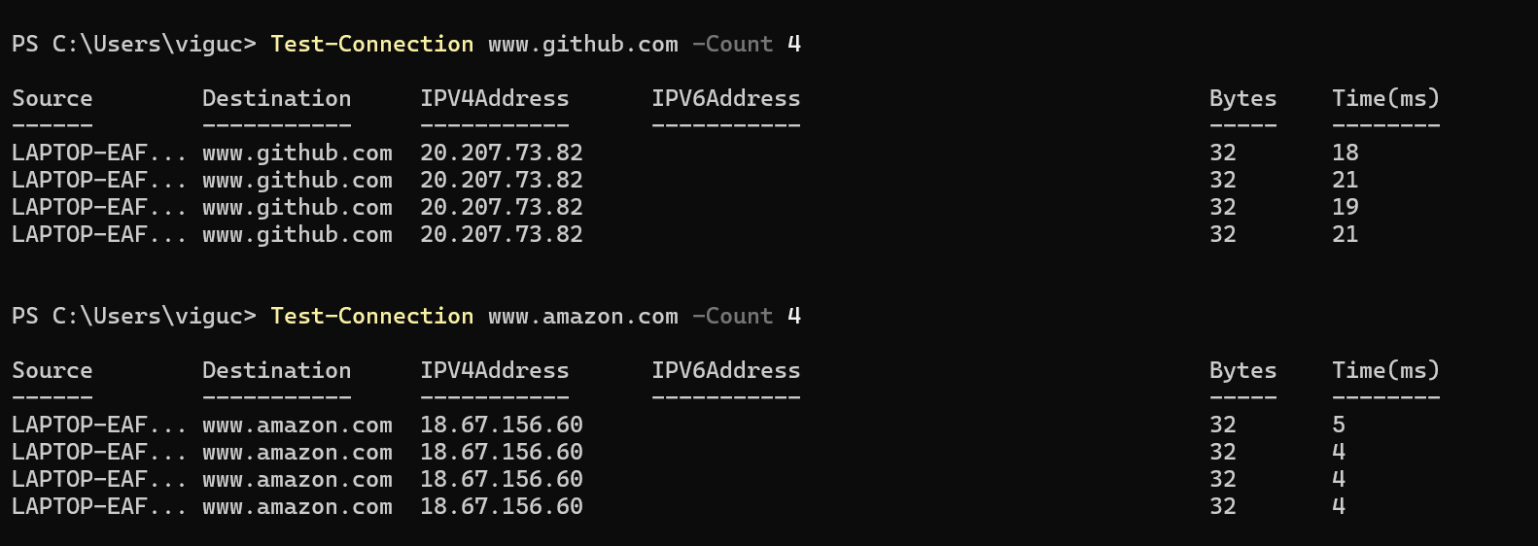

**nslookup command:**

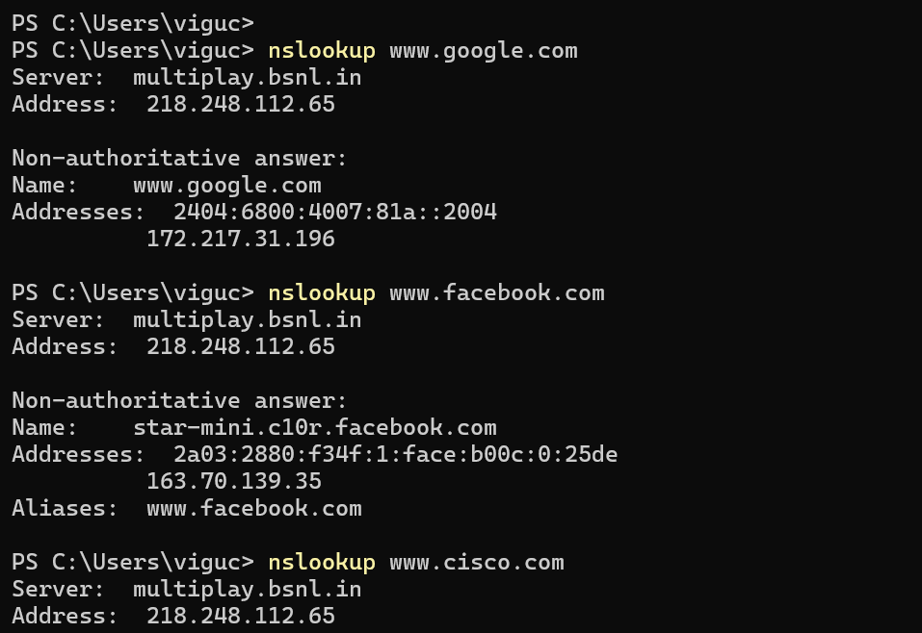

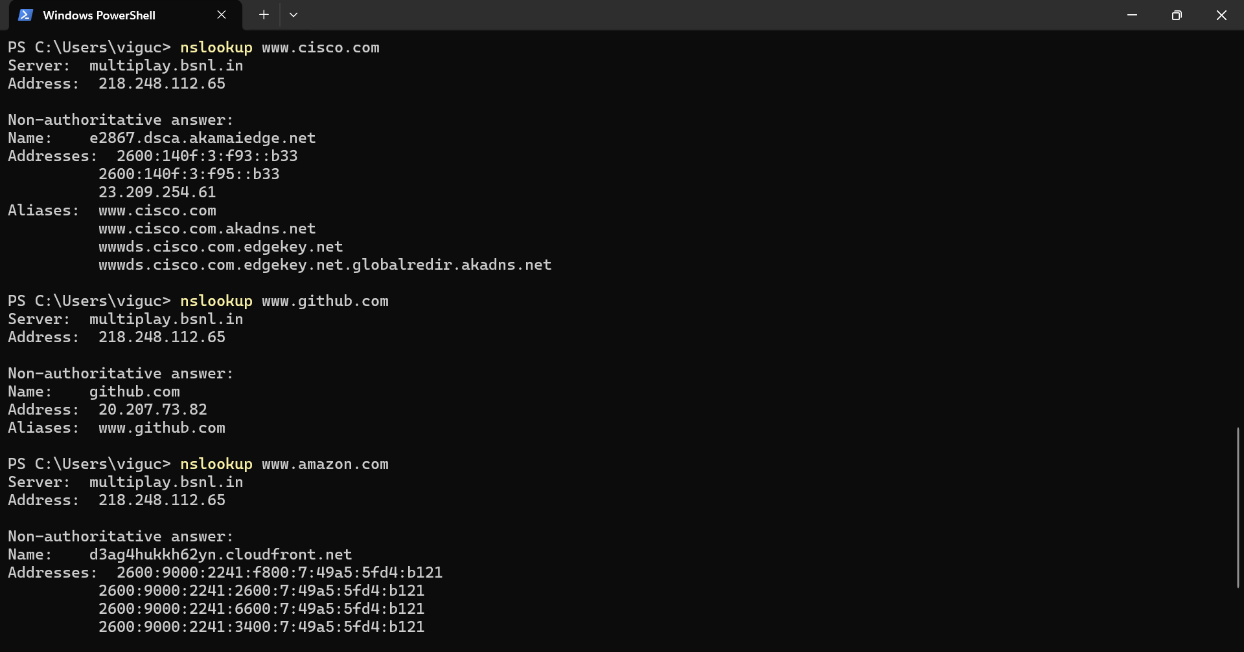

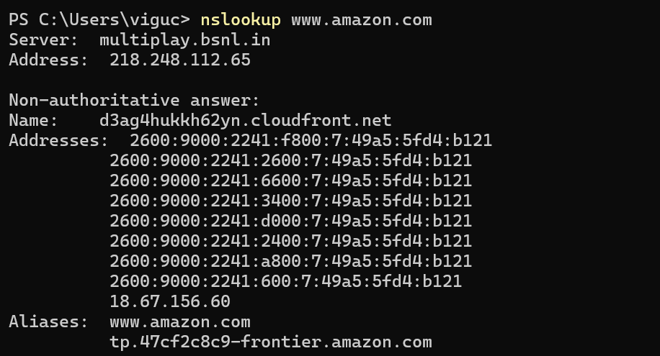

**Verification:**

**For Test-connection:**

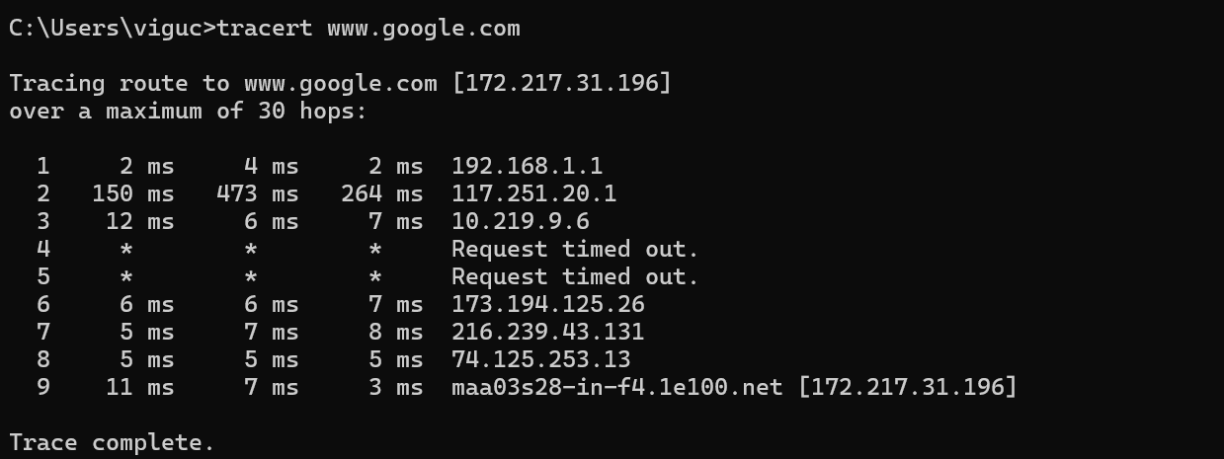

**For nslookup:**

